NEPAL ENGINEERING COLLEGE

( Affiliated To Pokhara University )

Changunarayan, Bhaktapur



Report on

Lab 2: Bit Plane Slicing

SUBMITTED BY : SUBMITTED TO:

Name: Suja Baral Department of Computer Roll no: 021 – 387 Science and Engineering Date: 05/ 07/ 2025 Department of Computer Science and Engineering

**Objectives**: To perform Bit Plane Slicing on an RGB image and save the resulting images in various file formats.

**Convert the Given RGB image into**

* Bit Plane Slicing
* Save image in different formats

**Code**

using System.Windows.Forms;

namespace Lab2

{

public partial class Form1 : Form

{

public Form1()

{

InitializeComponent();

comboBox1.Items.AddRange(new string[] { "0", "1", "2", "3", "4", "5", "6", "7" });

comboBox1.SelectedIndex = 0;

}

Bitmap originalBitmap;

private void Load_Click(object sender, EventArgs e)

{

OpenFileDialog ofd = new OpenFileDialog();

if (ofd.ShowDialog() == DialogResult.OK)

{

originalBitmap = new Bitmap(ofd.FileName);

pictureBox1.Image = originalBitmap;

}

}

private Bitmap ExtractBitPlane(Bitmap bmp, int bit)

{

Bitmap result = new Bitmap(bmp.Width, bmp.Height);

for (int y = 0; y < bmp.Height; y++)

{

for (int x = 0; x < bmp.Width; x++)

{

Color pixel = bmp.GetPixel(x, y);

//Convert Greyscale

int grey = (int)(0.3 * pixel.R + 0.59 * pixel.G + 0.11 * pixel.B);

int bitValue = (grey >> bit) & 1;

int colorValue = bitValue * 255;

Color newPixel = Color.FromArgb(colorValue, colorValue, colorValue);

result.SetPixel(x, y, newPixel);

}

}

return result;

}

private void Proceed_Click(object sender, EventArgs e)

{

if (pictureBox1.Image != null)

{

int Bitplane = int.Parse(comboBox1.SelectedItem.ToString());

Bitmap exactbitplane = ExtractBitPlane(originalBitmap, Bitplane);

pictureBox2.Image = exactbitplane;

}

}

}

}

**OUTPUT**

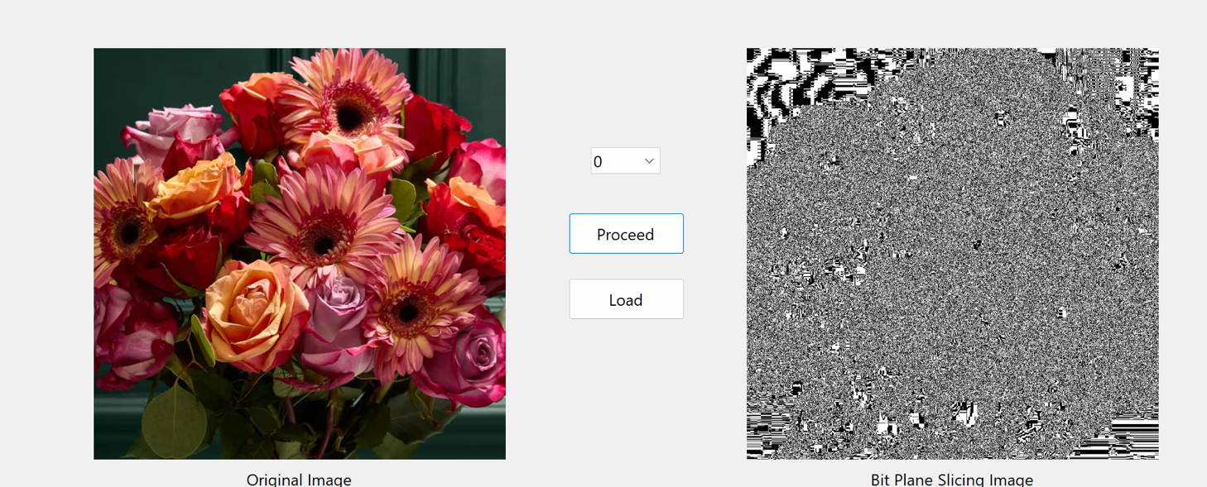

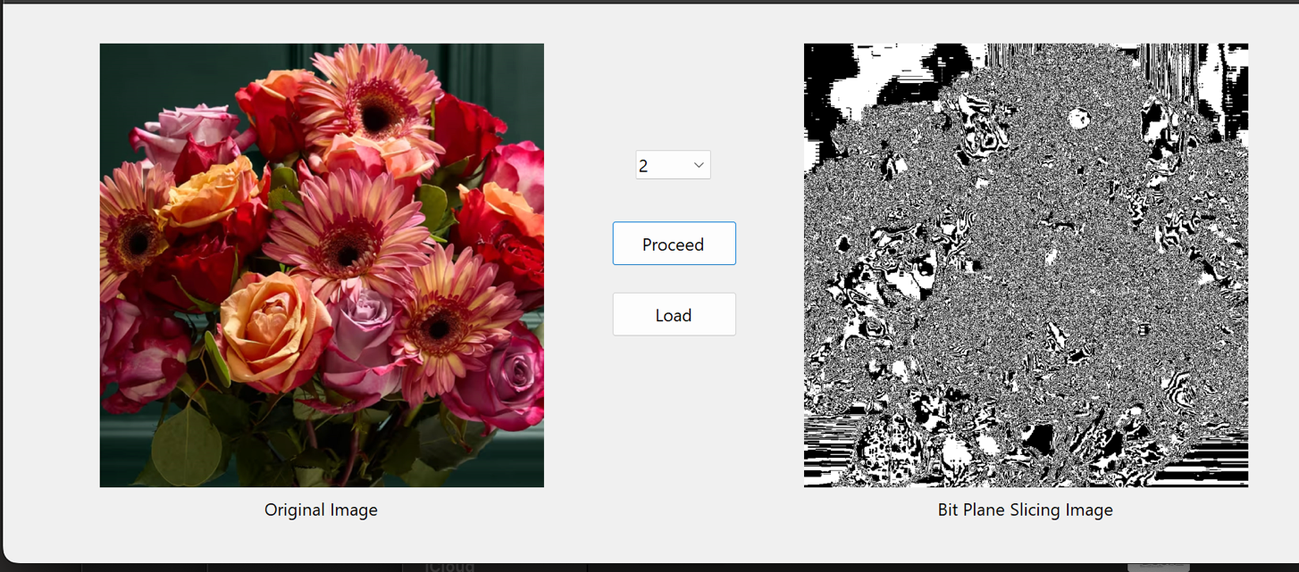

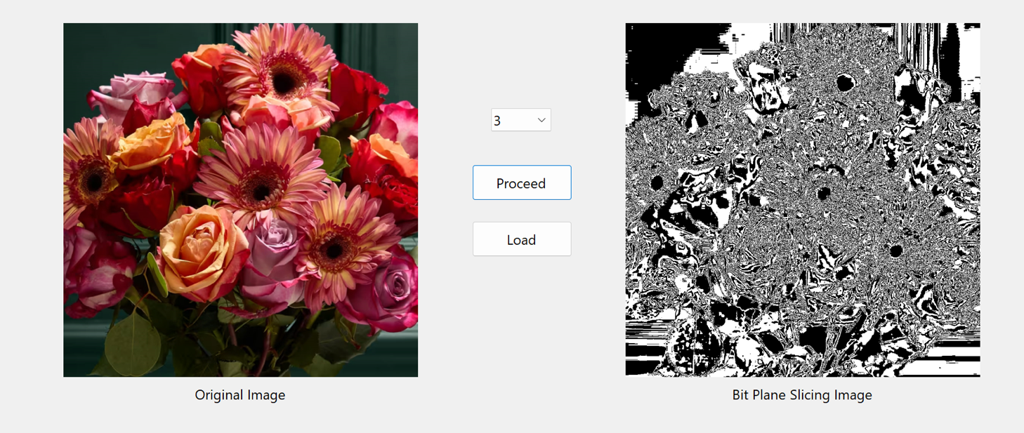

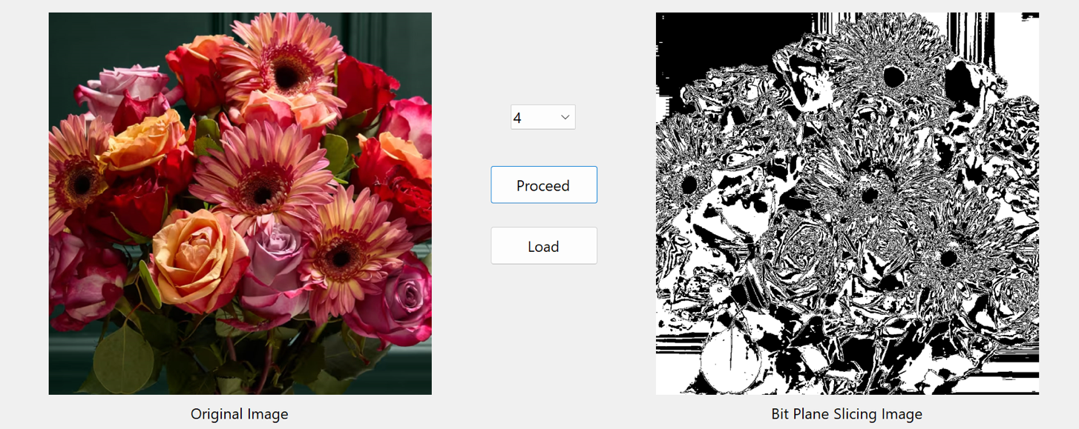

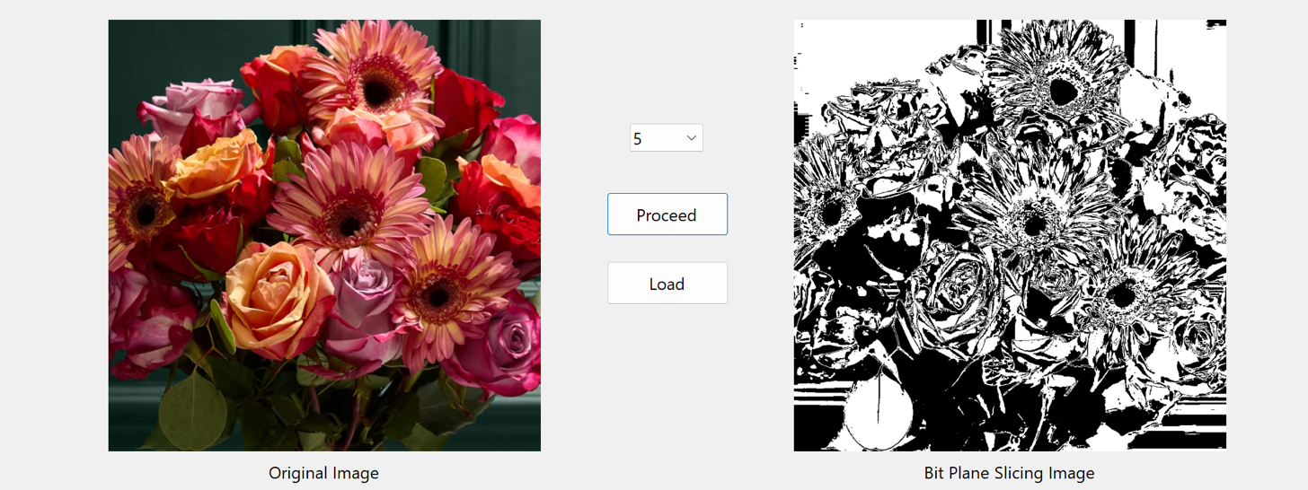

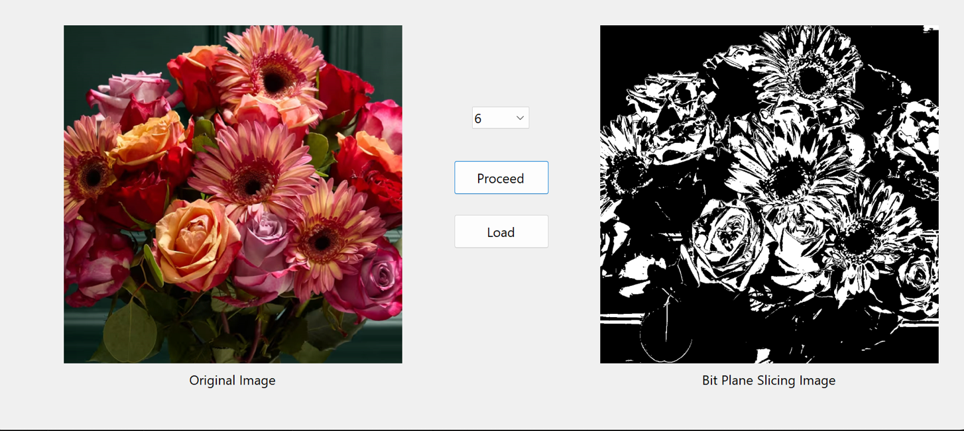

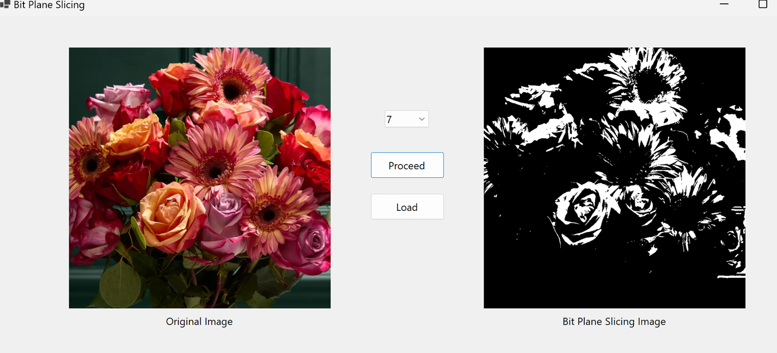

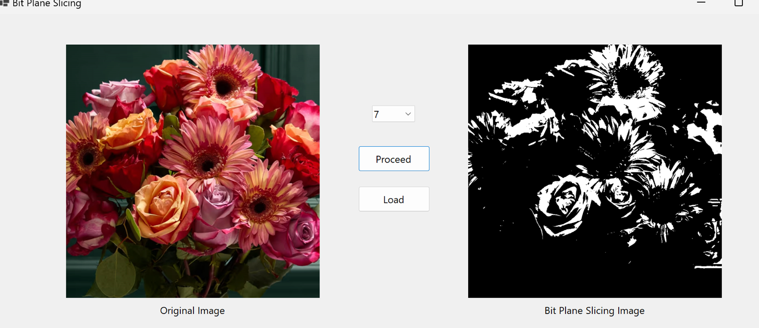

**OBSERVATION**

Bit Plane Slicing was applied to the RGB image, successfully separating it into individual bit planes. Each bit plane revealed different levels of detail, with higher-order bits capturing the most significant visual features and lower-order bits displaying finer or less noticeable details. The processed images were also saved in multiple formats such as JPEG, PNG, and BMP without any noticeable data loss.

**CONCLUSION**

The experiment demonstrated that Bit Plane Slicing is an effective technique for analyzing the contribution of each bit to the overall image. It helps in understanding image compression, enhancement, and data hiding techniques. Saving the images in different formats ensured compatibility and preserved the visual information across platforms.